Open Source Systems

Unit 1 Practical

W1-Exercise 1
The phpinfo() function, returns details about php along with a list of all the built in variables available to you. Following the instructions on the separate handout, create the script below and save it as wk1ex1.php, then run it through the browser.
<?php phpinfo(); ?>

W1-Exercise 1 Result:

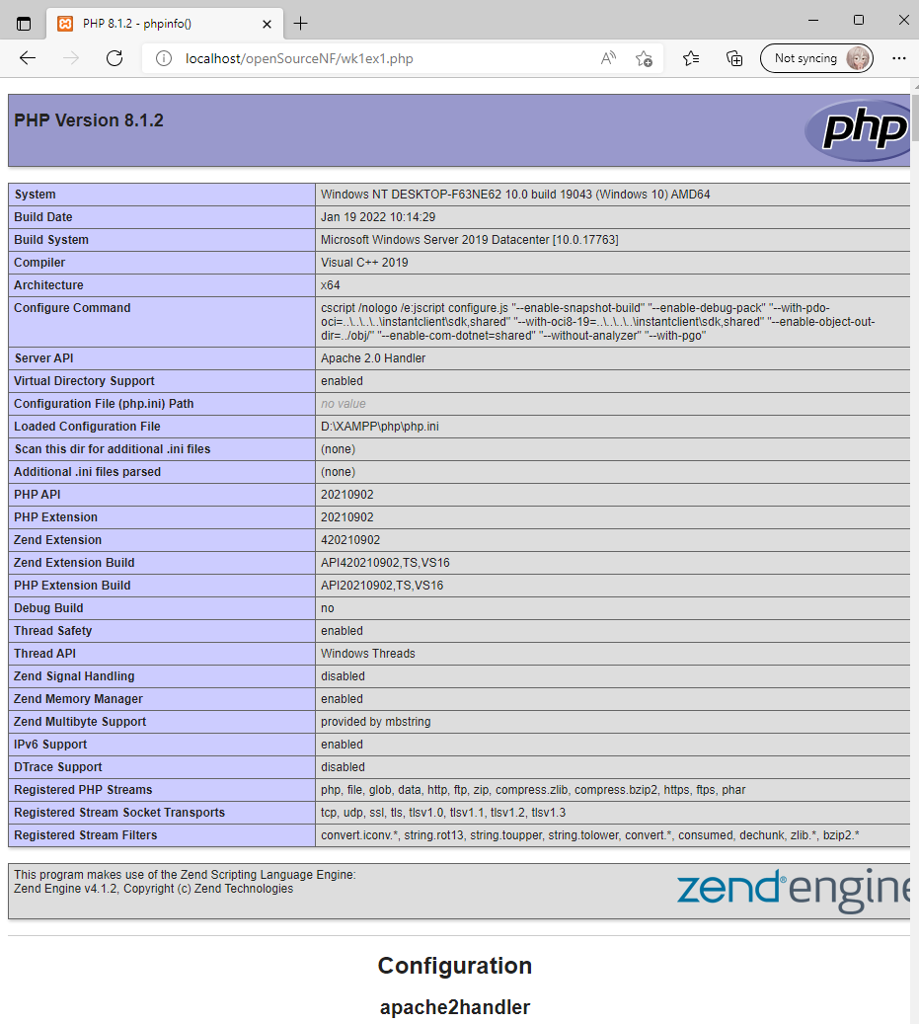

W1-Exercise 2
One of the built in variables is the $_SERVER array which contains information about the web server. By passing the argument "HTTP_USER_AGENT" you can obtain information about the browser the client is using. Save the following script as wk1ex2.php and then run it.

<?php echo $_SERVER["HTTP_USER_AGENT"]; ?>

Try passing the following arguments
- “SERVER_NAME”
- “SERVER_PROTOCOL”

W1-Exercise 2 Result:

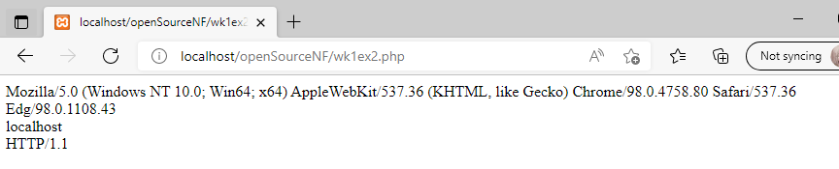

W1-Exercise 2 Changes:
- Added the arguments “SERVER_NAME” and “SERVER_PROTOCOL”

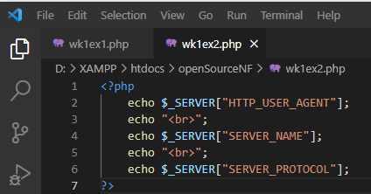

W1- Exercise 3
The next script will print “Blimmy it worked !” on the screen. Enter the script below into your editor and save it as wk1ex3.php
<html>
<body>
<?php
echo “Blimmy it worked !”;
?>
</body>
</html>

The php code is enclosed by the <?php start tag and the ?> end tag and the echo command displays the text between the double quotation marks.

W1-Exercise 3 Result:

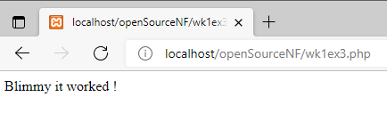

W1-Exercise 4
Our next exercise will display the current date. Name the file wk1ex4.php

<html>
<body>
<?php
echo gmdate(“M d Y”);
?>
</body>
</html>

The function gmdate() returns the current Greenwich Mean Time date based on the format specified by the string that is passed as an argument.

W1-Exercise 4 Result:

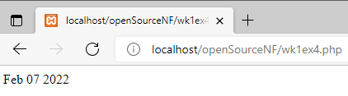

Try the following formats
- “D”

W1-Exercise 4 Changes and Result:

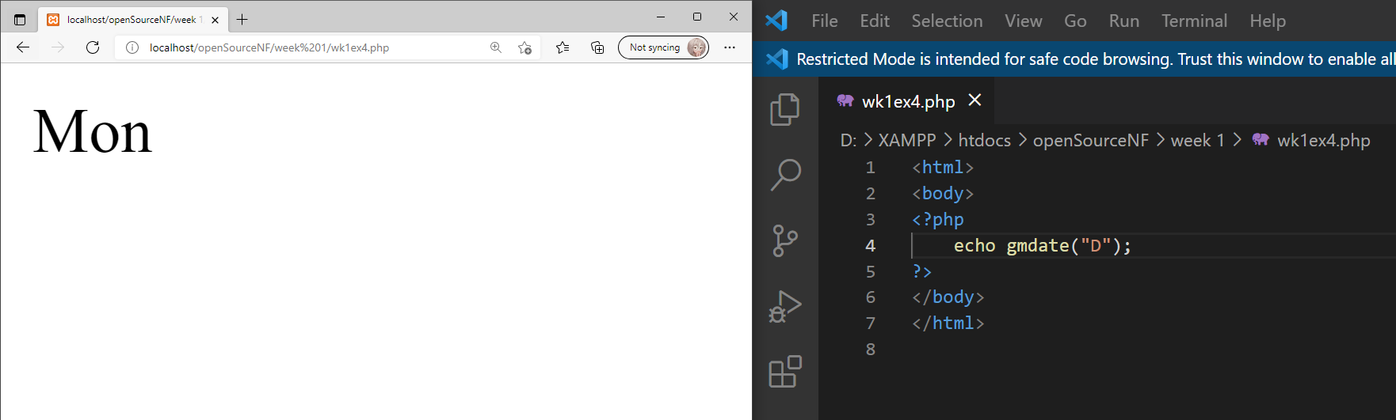

- “d m Y”

W1-Exercise 4 Changes and Result:

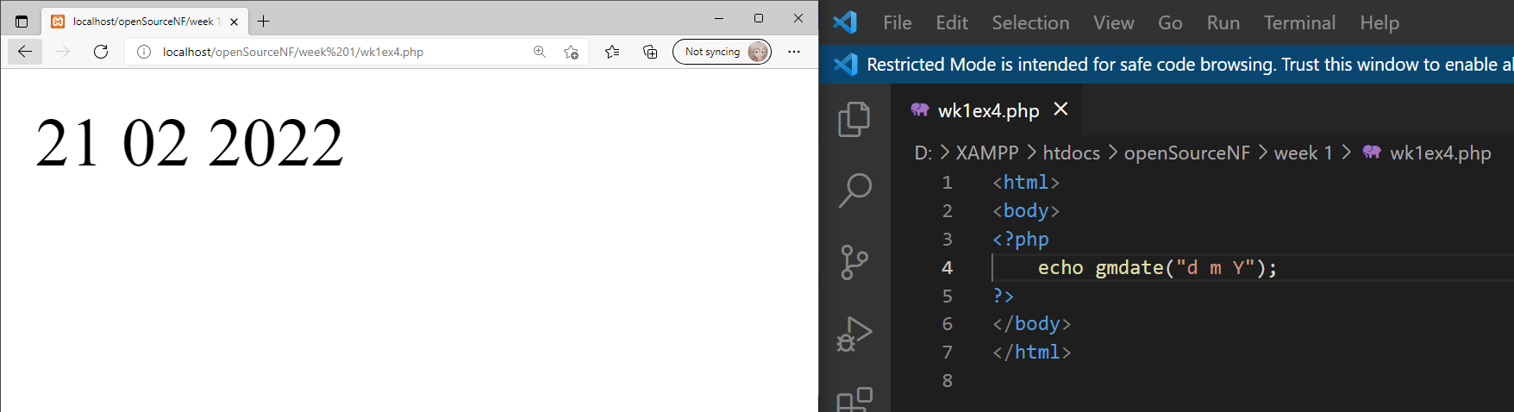

- “z”

W1-Exercise 4 Changes and Result:

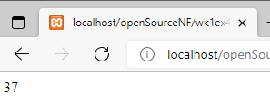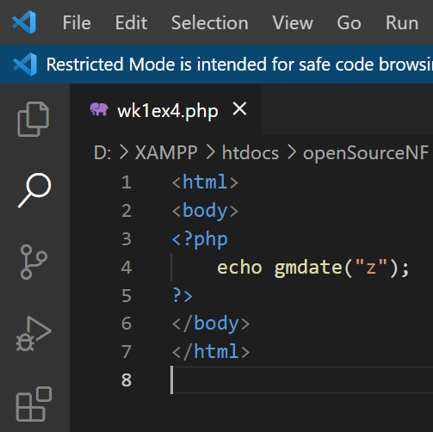
What does the last argument represent ?

It returns the number of days since the start of the year.

W1-Exercise 5
We can introduce variables into our scripts without prior declaration. Save the following script as wk1ex5.php and display it through the browser.
<html>
<body>
<?php
$myfavouritemodule = “Internet Systems Development”;
echo $myfavouritemodule;
?>
</body>
</html>

Within php all variables begin with a $. Php is case sensitive so the variable $age is not the same variable as $AGE or $Age.

W1-Exercise 5 Result:

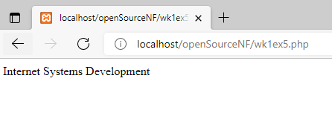

W1-Exercise 6
Exercise 5 assigned a string ( enclosed in double quotation marks ) to a variable, as with other languages php provides a means of concatenation ( adding one string to another ) using the full stop character “.” Save the following script as wk1ex6.php
<html>
<body>
<?php
$firstname = “Richard”;
$lastname = “Mather”;
$name = $firstname . $lastname;
echo $name;
?>
</body>
</html>

W1-Exercise 6 Result:

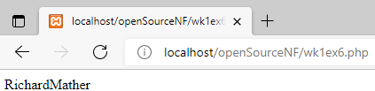

The problem with the above exercise is that there is no space between the first and last name.

W1-Exercise 6 Changes:
- Introduce a new variable $space and assign it a value of “ “. Include the new variable in the concatenates statement and run the script.

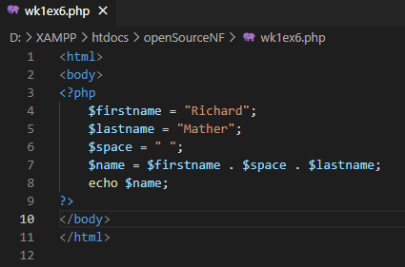

W1-Exercise 6 Result:

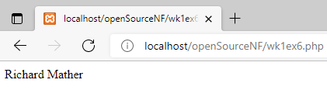

W1- Exercise 7
In addition to the string type we can introduce integer and double types into our scripts and carry out calculations using the following operators
+ addition
* multiplication
- subtraction
/ division
% Modulus

Save the following script as wk1ex7.php
<html>
<body>
<?php
$hourlyrate = 5.75;
$hoursperweek = 40;
$gross = $hourlyrate * $hoursperweek;
echo $gross;
?>
</body>
</html>

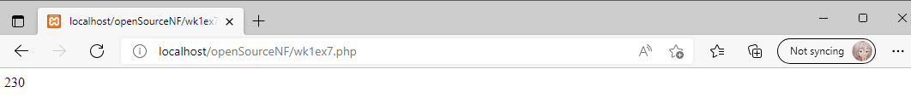

W1-Exercise 7 Changes:
- The above script calculates my gross wage. Modify it so that it calculates my net wage ( after tax ) based on a tax rate of 22%.

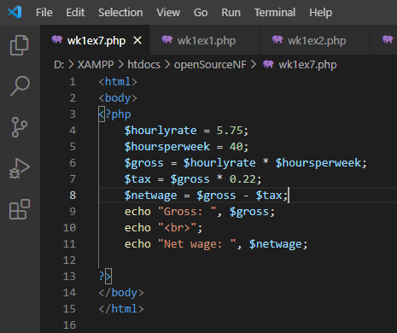

W1-Exercise 7 Result:

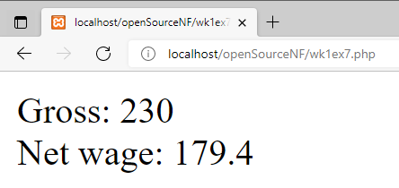

W1-Exercise 8

Sign up for an account with https://www.sololearn.com and complete the first unit “Basic Syntax” on the SoloLearn PHP course either via the web or via the mobile: https://www.sololearn.com/Play/PHP

You will be asked to complete further units in future handouts.

In your final logbook/handout, you will be asked to provide evidence that you completed the whole course in the form of a screenshot of your progress or a screenshot of the certificate of completion.

